URL to site: http://www.madebysofa.com/

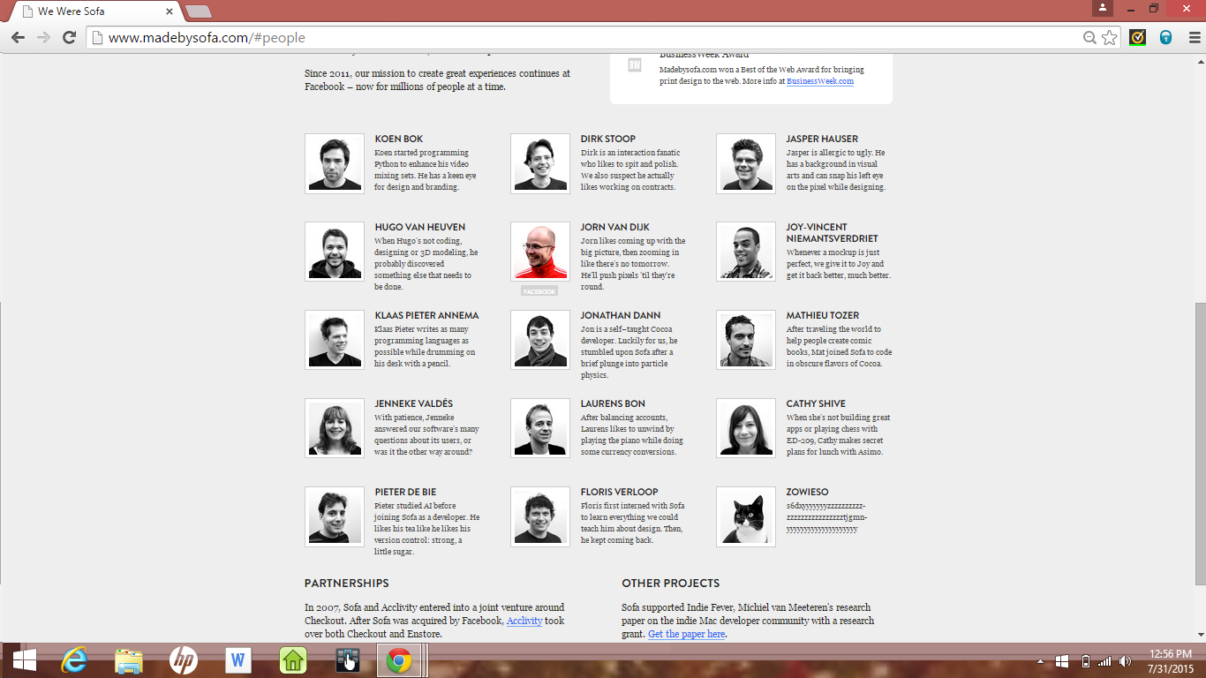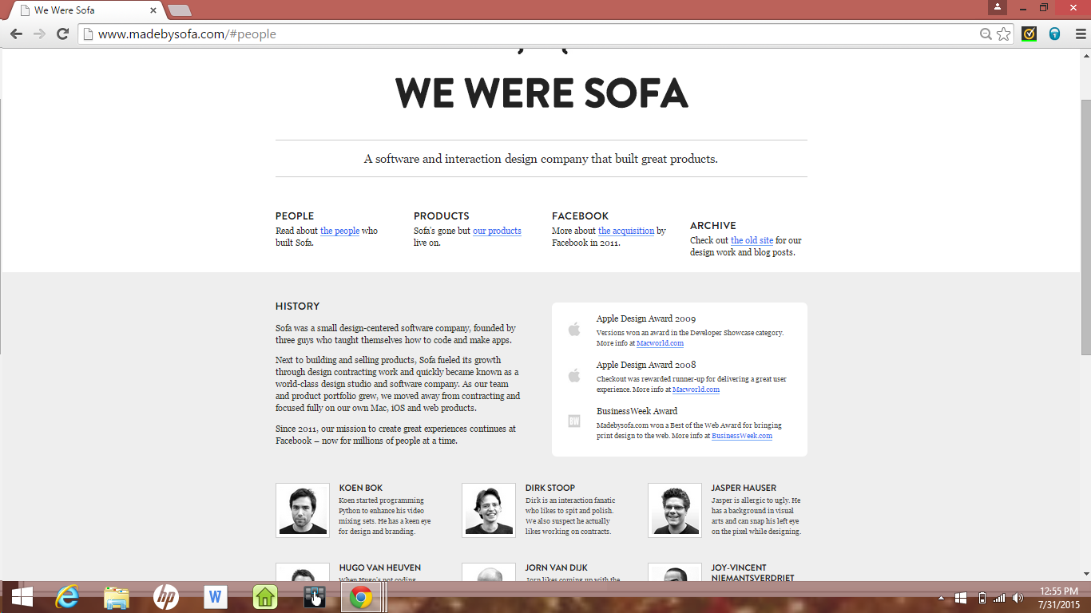

**Inspiration**: I chose http://www.madebysofa.com/ because of its simplicity. It has a clean background with two tones that makes the site a little less dull. It isn't super flashy but it catches your attention with the symmetry and the overall layout. I like the interactive part of hovering over the images under the "people" section, and giving a black and white picture some color. I am going for a look similar to this page, simple yet catchy.

**Things I like about my project:** Not to beat a dead horse, but as I stated the simplicity is one thing I'm particularly proud of. I enjoy a flashy sites but elegant sites peak my interest a bit more. I also like that I stepped out of my comfort zone and practiced a couple of things that weren't in the WDC curriculum. Under my "interest" page I put in a video and was pleased how that turned out.

**Struggles:** I think trying to find a balance of proportion was a bit of a struggle. What I am talking about in particular is my font size. My font was rendering pretty big at first and still is. I think adjusting the overall font size in my body css will help with that. I'm still struggling with making my site responsive. Which is a good lead in to my next section. :D

**What did you learn from making your project responsive?:** It's harder than it looks! I agree with how GA taught responsiveness. As a developer, your goal shouldn't be targeting the screen size of a particular mobile or tablet device. A developer should set a range(min and max screen width) that encompasses a range of pixels that is somewhat uniform to various devices. Meaning find a happy medium that will work with your average "smart" device. I also had a little bit of a hard time realizing that you should only put elements that you want to be resized(to be more responsive) inside of the media quires. This is still a work in progress for me, but I enjoy learning.

**The Good, The Bad and The Down Right UGLY!**

**The good**: I chose http://squarespace.com/home/overview/ out of group one of the options on the websites to choose from. It's busy enough to capture your attention, but has a touch of simplicity that I enjoy. It has a good layout and I like that responsiveness to the site.

**The downright UGLY:** I chose to critique Space Jam's website. It's pretty evident that the site was built in the 90's. It has a horrible background and typography. The only thing that I am impressed about with the site is the workable links. Everything else is horrible! In fact the whole movie idea was bad from the get go. I applaud Michael Jordan for trying baseball, but he sort of ruined his career getting into acting. I digress! Unpleasant and very busy site! It was a nostalgic experience for me looking at that site.